**MODIFIED TEST CONSENT FORM**

**TITLE OF RESEARCH STUDY: *Validation of a personal breath analyzer for diet and energy expenditure assessment and management***

**INTRODUCTION**

The purposes of this form are to provide you (as a prospective research study participant) information that may affect your decision as to whether or not to participate in this research and to record the consent of those who agree to be involved in the study.

**RESEARCHERS**

Researchers: NJ Tao, Erica Forzani, Fang Chen, Corrie Whisner, Flavia Soto, Melissa Herbst-Kralovetz, Alicia Muhleisen, Craig Stump, Karen Herbst, Yulia Abidov, Shubh Kaur, Ronnie Williams, Gary Patterson, and Mirna Terrera at the Center for Bioelectronics and Biosensors at the Biodesign Institute, ASU invite your participation in a research study.

**STUDY PURPOSE**

The purpose of the research is to determine energy expenditure rates and diet and/ physical activity metabolic features of an individual using current state technologies and a new technology created at the Center for Bioelectronics and Biosensors.

**DESCRIPTION OF RESEARCH STUDY**

If you decide to participate, then as a study participant you will join a study involving research of metabolic physiological parameters that are measured through the breath of the individuals, together with other physical parameters (weight, height, date of birth, fat and lean body composition via skin-fold measurements, bio-impedance, heart rate, blood pressure, and breathing rate) assessed in the laboratory by a trained researcher, and a questionnaire about diary physical activities. The study will involve withdrawn of breath samples at resting conditions, and under diets or physical activities regimes as described below, and blood and urine withdrawals for analysis of glucose, ketones, lipids, proteins, and biomarkers related to fat oxidation or carbohydrate oxidation metabolism.

Blood withdrawals will be done using fingertip blood collection method. Commercial devices for home use (e.g.: glucometer, ketometer, etc) will be used for analyzing glucose, ketones, and related parameters. Disposal of hazard material (strips, lancets, needles, and wipes) will be performed in special containers for biohazards provided by Biodesign Institute for this purpose.

In some cases, the study may involve the assessment of Body composition via DEXA (Dual-energy X-ray absorptiometry). You can participate in the DEXA only if you are a healthy adult, do not have Chronic Obstructive Pulmonary Disease (COPD) and have not used nuclear isotopes in the last 30 days. If you are included in the group where a DEXA scan is involved a separate authorization will be required on this consent form.

DEXA procedure involves of the following actions:

You will be asked to lie face up on a padded table for 7 minutes while the scanner arm of the DEXA machine passes over the entire body. The scanner will not enclose or touch you and you will wear regular clothing (no metal allowed).  Radiation exposure (1-4 microSieverts) is within an acceptable range as based on the US FDA guidance. Anytime you are exposed to radiation there is potential risk. The amount of radiation (1-4 microSieverts) that you would be exposed to is quite minimal. For example, you would receive radiation exposure of approximately 80 microSieverts on a transatlantic airline flight of 8 hours, 50 microSieverts living in Denver, Colorado, at an elevation of 5,000 feet for approximately 4 weeks, or 30 to 40 microSieverts during a typical chest x-ray.   If there is ANY chance of being pregnant then you should not undergo DEXA scanning.  All female participants will be asked to take a urine pregnancy test immediately before each DEXA scan. If you become pregnant during the course of the study, you will need to inform the staff, and would be excluded from the DEXA portion of the study. A certified X-ray technician will complete all DEXA scans.

Testing will be done with a breath analyzer developed at ASU, and commercial analyzers. The breath analyzer developed at ASU is named Breezing (Figure 1). Breezing is an indirect calorimetry analyzer that measures the rate of oxygen consumption and carbon dioxide production, and determines how much energy the body is burning due to the metabolism of nutrients (named Resting Energy Expenditure, REE), and the type of nutrients the body uses to produce energy (Energy source = respiratory quotient, RQ). The Breezing is a cellphone-size, battery-operated, portable technology that syncs with smartphones. You will be asked to breathe into a mouthpiece connected to the Breezing device; the data will be then beamed wirelessly to a cellphone. Your REE, and RQ will be determined and displayed on the cell phone screen in conjunction with an estimate of total calories burn in a day (total energy expenditure, TEE). The Breezing has a 99.8% correlation with the gold standard method, Douglas Bag (Forzani, Tao, et.al, Clinical Nutrition, 2013), and it is a potential commercial product for weight management fitness and health (for more details regarding this device talk to Erica Forzani).

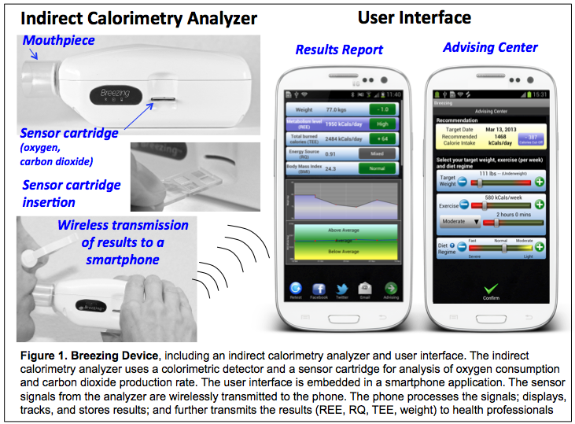

Both the Breezing analyzer, and the commercial analyzers have a disposable and sterilized mouthpiece that can be inserted in your mouth. You will be asked to breathe into the mouthpiece to collect the exhaled breath biomarkers. In the case, of the breath analyzer developed at ASU, a predefined breath volume between 0.5 L -10.0 L will be collected, and analyzed. The results will be displayed and stored for further later analysis.

It is important to inform you that two of the investigators of this study, Drs. NJ Tao and Erica Forzani, declare a financial interest because the Breezing device is manufactured by TF Health Co. and Drs. Tao and Forzani are co-founders and investors of the company.

In addition, breath samples will be taken from each individual and analyzed with reference methods for oxygen (electrochemical detection or paramagnetic resonance spectroscopy), carbon dioxide (infrared spectroscopy), acetone (Gas Chromatography/Mass Spectrometry or Selective Ion Flow Tube-Mass Spectrometry (SIFT-MS)), and volatile organic compounds (such as isoprene, ethane, acetone, ammonia via SIFT-MS). In addition, metabolic rate instruments, including VO2 lab (from VacuMed), TrueOne 2400 (from ParvoMedics) or equivalent, and/or portable Oxycon Mobile (Viasys Healthcare) or BodyGem (Microlife Medical) will be used.

In addition, you will be tested with activity trackers, which will be allocated in some part of your body. The researchers of the study will make sure you are comfortable with the use location of the activity tracker. Activity trackers to be tested include Striiv, Jawbone, Omron, Fitbit, and others of similar design with a belt clip or in the shape of a wearable such as a wristband or chest band.

In addition, some of the participants will be asked to test their REE with Breezing device, and record their weight, physical activity level, and/or diets, while doing independent living. The participants will be asked to report those results to the study investigators.

You will be included in one of the following study groups:

**1) Physical activity group:** A group of at least *10 individuals* will be studied under resting and different physical activity conditions.

*Resting conditions:* Energy Expenditure Rate (EER) at resting conditions (resting energy expenditure: REE) will be determined. The individuals will be asked to have some of the following conditions: a) a postprandial state of at least 4 hrs after a light meal (< 500 Kcal), or 8 hrs after a medium/heavy meal, b) no caffeine beverage for 4 hrs, c) no nicotine use for 8 hrs, d) abstinence of light-to-moderate exercise for 18-24 hr or heavy exercise for 48 hrs, and e) restful sleep requirements of 8-12 hrs. EER will be determined after the individual is sitting comfortably for 10 min. while listening to soft music.

*Physical activity conditions:* The individuals will be asked to engage in physical activities of increasing energy EER. For each activity, the subject will be allowed to establish the baseline condition for at least 5 mins. The later parameter will be obtained when the subject engages the following activities: sitting quietly for 15 mins, walking slowly for 15 mins, walking normally for 15 mins, walking fast for 15 mins, and biking with a resistance defined as normal (by the subject) for 15 mins, or other resitance training exercise. Each activity will be separated by a 10-mins break. The REE will be evaluated, and results will be expected to follow the incremental energy expenditure demand of the activities when compared to basal metabolic state. In addition, combinations of descriptions above with different times and activities will be performed.

*Aerobic vs anaerobic exercise:* A subgroup of individuals will be tested during a workout with incremental resistance on a treadmill machine. The EER, and the respiratory quotient (RQ) defined as the ratio of produced carbon dioxide / consumed oxygen will be calculated from the biomarkers measurement of the individuals’ breath. RQ and EER values will be evaluated as a function of time to evaluate the device’s capability for discriminating the two conditions: aerobic with RQ ≤1 at initial state, and anaerobic with RQ > 1 after considerable effort has been performed (this last condition is typically observed when the individual has reached 80%+ of his/her maximum heart rate capacity).

**NOTE: your capability to be included in the physical activity group will be determined based on the answer you provide in a health questionnaire.**

**2) Diet test group**: Three different types of diet tests will be performed: carbohydrate vs fat diets; ordinary food restaurant diet; and low-calorie diet. There is no cost for the food involved in the study. The patients will be instructed to follow particular diets with the associated cost to it.

*Carbohydrate vs fat diets:* a group of individuals (not smaller than four) will be exposed to carbohydrates- and fat-rich diets for 3 days. High carbohydrates-rich diets will include: cereals, grains and bread such as bagel, white bread, whole wheat bread, white rice, barley, oatmeal, spaghetti, pasta with light sauces (e.g. tomato), and fruits such as apricot, dates, blueberry, banana, grapes, apple, orange, pear, pineapple, strawberry, watermelon and raisins. High fat-rich diets will include: whole milk, ice cream, eggs, bacon, creamy pies, chocolate, and burgers. Each individual will be asked to maintain a record of their diets during the study period, using their phone camera, personal notes and/or diet phone application (e.g. GoMeals for iPhone). The focus of this test is to evaluate the capability of the breath analyzer to perform discrimination of respiratory quotients and acetone indicative of carbohydrates (close to 1) or fat (close to 0.7) during three days of consecutive controlled-diet intake.

*Ordinary food diet:* a group of individuals will be exposed to diets based on meals with well-defined calories, and fat, carbohydrates and protein content. The meals will be have food purchase on local stores, or from well-known restaurants such as fast food restaurants (e.g. McDonald’s, Panda Express, Burger Kings) and each meal will be recorded in a picture, and diary (personal notes or GoMeals iPhone app). Breath samples will be taken at resting conditions and analyzed to obtain RQ and acetone values, using the breath analyzer, and conventional metabolic rate instruments. The RQ values will be used to define the particular dominant type of food consumption. The diagnosis of type of food intake and the food intake reported by individuals will be compared.

*Low-calorie diet:* a group of individuals will be evaluated under weight-loss diet conditions for variable periods of few days to 12 months. The dietary intake will be variable, the individuals will be eating variable percentages of total dairy calories required to cover their REE measured before starting the diet, using conventional metabolic rate instruments. Variable percentage of REE of calorie intake includes from fasting for a day, to larger percentages. The restriction of fasting will be applied only to one or two days in a week. The values of RQ and acetone will be evaluated.

*Calogenetic Balance Intervention:* Adaptation of individual’s nutritional habits based on a calorie intake recommendation goal will be applied. The calorie intake recommendation goal will be determined from total energy expenditure (TEE), which is assessed from the REE measurement. The researchers will provide the calorie intake recommendation for 24 hrs, and the corresponding food intake consisting of the following proportion: 50-60% carbohydrates, 25-35% fats, and 15-20% proteins. In addition, the participants will be advised to consume more fruit and vegetables.

In addition, diary calorie intake, body fat composition and weight, using conventional methods will be diary recorded and measured to estimate the EER based on body physical parameters (EERBPP). In parallel, actual Metabolic Energy Expenditure Rate (EERMET) and acetone levels will be evaluated, using the breath analyzer. The values of EERBPP and EERMET will be measured and compared to establish the validity of the breath analyzer to determine the accuracy of EERMET and acetone levels from the breath analyzer to predict weight lost.

***Testing events:*** For each test, the parameters of each subject will be collected by triplicate or quadruplicate, and stored in a database for statistic analysis.

**NOTE: you will be given the option to engage any of the above mentioned diet groups.**

If you say YES, then your participation will last for one year from the date of your signature at the Center for Bioelectronics and Biosensors, Biodesign Institute, ASU.

Approximately 30-80 of subjects will be participating in this study at local level.

***Additional test: Total energy expenditure in free-living conditions***

In order to measure the amount of energy that your body will use during a 1 or 2-week period, we will ask you to drink a cup of doubly labeled water (it contains harmless, heavy water molecules, small amounts of which are found in the tap water). The doubly labeled water will not quite double the amount of heavy water already in your body. You will be asked to collect small samples (1/4 cup) of your urine on the first and the last day (day 7 or 14) of this protocol. The first day, the urine will be collected over a four-hour period (one urine sample per hour). These measurements from your urine tell us how much energy (calories) your body uses over the one or two-week period of the study. Before the second visit, we will ask you not to eat anything for six hours before coming to the clinic. You may drink water. At the second visit we will measure your height and weight and ask you to give two more urine samples in the clinic, each about one hour apart. The urine will be used to measure energy expenditure.

You will have to eat a normal dinner between 5 and 8 pm the night before and then not eat or drink foods or beverages that contain calories. In the morning, you will come to our lab and sit down on a comfortable chair. During this time you will remain at sit, and a mouthpiece will be placed over your mouth to measure the amount calories your body burn per day at resting state.

*Study at University of Arizona*: the study will be conducted in a separate group, and it will follow the specific consent form shown in Appendix 1 of this document. If you do belong to this group, sign the consent form corresponding to Appendix 1. If you so not belong to this group, disregard Appendix 1, and signed the current consent form.

**RISKS**

As with any research, there is some possibility that you may be subject to risks that have not yet been identified. Potential risks may be associated with physical activities during the test, but in any case, you will be allow to stop the activity if you feel uncomfortable with it or if you feel any physical discomfort. For the DEXA participants, radiation exposure (1-4 microSieverts) is within an acceptable range as based on the US FDA guidance. Anytime you are exposed to radiation there is potential risk. The amount of radiation (1-4 microSieverts) that you would be exposed to is quite minimal. For example, you would receive radiation exposure of approximately 80 microSieverts on a transatlantic airline flight of 8 hours, 50 microSieverts living in Denver, Colorado, at an elevation of 5,000 feet for approximately 4 weeks, or 30 to 40 microSieverts during a typical chest x-ray.   All female participants will be required to take a urine pregnancy test immediately before each DEXA scan and will be excluded from participation in this portion of the research.

**BENEFITS**

The possible/main benefits of your participation in the research are the access to the individual metabolic profile.

**NEW INFORMATION**

If the researchers find new information during the study that would reasonably change your decision about participating, then they will provide this information to you.

**CONFIDENTIALITY**

All information obtained in this study is strictly confidential unless disclosure is required by law.

The results of this research study may be used in reports, presentations, and publications, but the researchers will not identify you. In order to maintain confidentiality, your records will be kept within researchers of this study, and the information will be secure within the security system at Biodesign Institute.

**WITHDRAWAL PRIVILEGE**

It is ok for you to say no. Even if you say yes now, you are free to say no later, and withdraw from the study at any time., and your decision will not affect your relationship with Arizona State University or otherwise cause a loss of benefits to which you might otherwise be entitled. In addition, if the subject is student, his/her nonparticipation or withdrawal from the study will not affect his/her grade.

**COSTS AND PAYMENTS**

The researchers want your decision about participating in the study to be absolutely voluntary. Yet they recognize that your participation may pose some inconvenience. We will accommodate your schedule at the best convenience for you. Depending in the study case, time dedication to the study either by physical presence or pursuing specific diet or physical activities will take 2 days to 1 week. You will be paid $50.00 for each day of participation.

**COMPENSATION FOR ILLNESS AND INJURY**

If you agree to participate in the study, then your consent does not waive any of your legal rights. However, no funds have been set aside to compensate you in the event of injury.

**VOLUNTARY CONSENT**

Any questions you have concerning the research study or your participation in the study, before or after your consent, will be answered by Erica Forzani, Gary Patterson, Craig Stump, Karen Herbst, Yulia Abidov, Shubh Kaur, Ronnie Williams or Mirna Terrera.

If you have questions about your rights as a subject/participant in this research, or if you feel you have been placed at risk; you can contact the Chair of the Human Subjects Institutional Review Board, through the ASU Office of Research Integrity and Assurance, at 480-965 6788.

This form explains the nature, demands, benefits and any risk of the project. By signing this form you agree knowingly to assume any risks involved. Remember, your participation is voluntary. You may choose not to participate or to withdraw your consent and discontinue participation at any time without penalty or loss of benefit. In signing this consent form, you are not waiving any legal claims, rights, or remedies. A copy of this consent form will be given (offered) to you.

Your signature below indicates that you consent to participate in the above study.

___________________________ _________________________ ____________

Subject's Signature Printed Name Date

**INVESTIGATOR’S STATEMENT**

"I certify that I have explained to the above individual the nature and purpose, the potential benefits and possible risks associated with participation in this research study, have answered any questions that have been raised, and have witnessed the above signature. These elements of Informed Consent conform to the Assurance given by Arizona State University to the Office for Human Research Protections to protect the rights of human subjects. I have provided (offered) the subject/participant a copy of this signed consent document."

Signature of Investigator______________________________________ Date_____________

Your signature below indicates that you consent to participate in the DEXA arm of the study.

___________________________ _________________________ ____________

Subject's Signature Printed Name Date

**INVESTIGATOR’S STATEMENT**

"I certify that I have explained to the above individual the nature and purpose, the potential benefits and possible risks associated with participation in this research study, have answered any questions that have been raised, and have witnessed the above signature. These elements of Informed Consent conform to the Assurance given by Arizona State University to the Office for Human Research Protections to protect the rights of human subjects. I have provided (offered) the subject/participant a copy of this signed consent document."

Signature of Investigator______________________________________ Date_____________

**Appendix 1. CONSENT FORM FOR UNIVERSITY OF ARIZONA**

***STUDY TITLE: Validation of a personal breath analyzer for diet and energy expenditure assessment and management***

**TITLE OF RESEARCH SUBSTUDY:** *A mobile personal tool for effective weight management*

**INTRODUCTION**

The purpose of this form is to provide you information that may affect your decision as to whether or not to participate in this research project, and to document the consent of those who agree to participate.

**RESEARCHERS**

Craig Stump, Karen Herbst, Yulia Abidov, Shubh Preet Kaur, Ronnie Williams, at the University Medical Center, University of Arizona, Tucson, Arizona. NJ Tao, Erica Forzani, and Mirna Terrera at the Center for Bioelectronics and Biosensors at the Biodesign Institute, Arizona State University, Tempe, Arizona.

**STUDY PURPOSE**

The purposes of the research are to:

***1-*** ***Compare health outcome measures for weight loss interventions using either 1.) a standard medically directed weight loss program, or 2.) the standard weight loss program aided by a mobile breath analyzer device (Breezing).***

These weight loss interventions will be implemented for a group of patients recruited from the Community, but primarily from the Medicine, Diabetes and Endocrinology Outpatient Clinics, at the University Medical Center.

Up to forty overweight adult patients (18-70 years old) with BMI between 25-42, and one or more of the following metabolic abnormalities: high blood sugar (>100mg/dL), high blood pressure (>135 mmHg), abnormal lipids, including elevated triglycerides, low HDL or Type 2 Diabetes with HbA1C between 6-8.5 will participate in the study. In addition, a spouse, partner, or household relative, may also participate in the study as a “co-participant”, to encourage additional home-based support. The co-participants will not use the *Breezing* device, however, their weight will be tracked together with the weight of the primary participant at the beginning and end of the study, and encouraged to do so at other designated study visits. The study duration will be 6 months. Overweight patients will be recruited, and randomly assigned to either the standard (n > 16) and or mobile device assisted (n > 16) weight loss groups (Fig. 1).

***2- To determine patients’ satisfaction with the new mobile health device.***

In order to evaluate the level of satisfaction while using the *Breezing* mobile health tool, patient surveys will be conducted for both the standard care and the mobile device assisted groups after completing the 6-month intervention. In the mobile device assisted group, patients will also evaluate their experience with the tool, as well asassess their perception as to the importance of energy expenditure, caloric requirements, and caloric intake during weight loss intervention.

**DESCRIPTION OF RESEARCH STUDY**

If you decide to participate in the study you will take part in the following activities.

***Standard Care Group:*** The participants assigned to this group will follow a standard weight loss program for 6-months. This will include instructions on meal portion control, identification of calorically dense food and drinks, healthy snacking choices, how to avoid “stress eating”, and how to track your movements and calorie intake via on-line, and mobile resources.

You will be instructed and assisted in reducing your daily caloric intake by 500-1000 calories from initial daily caloric estimates, and will target a weight loss goal of 7% of total body weight over the 6 months.

You will be counseled on how to increase caloric expenditure through moderate intensity exercise (walking or equivalent) toward a goal of 150 min per week as tolerated. This will be provided by investigators during specific clinic visits and electronically (e-mail and/or text messaging). An electronic pad will be issued to you for these communications as well as for you to record your weight, food intake and physical activity. The pad will also be equipped with an "app" that will also guide your weight loss efforts and provide a large library of food items with caloric content information.

In addition to the baseline visit you will return to the clinic three additional times (after 1 month, 3 months and 6 months). All visits will include physical measurements including body mass index (BMI) based on height and weight, blood pressure, and body composition (fat percentage). Body composition will be assessed during clinic visits by skinfold calipers and body circumference measurements, or by bioimpedance. Waist circumference (cm) will be measured at the umbilicus.

At the baseline visit and at the end of the study blood will be drawn from an arm vein (<10 cc each occasion) or from fingerstick, and Resting Energy Expenditure (REE) will be determined using the *Breezing* device, a breath analyzer that calculates the calories burned per day while at rest (see below more details).

The blood withdrawal from vein or fingerstick will provide analysis of your fasting blood sugar, HbA1c which is a 3 month estimate of your blood sugar control, lipid panel including cholesterol, and other blood biomarkers related to your metabolism. Blood withdrawals will be done using sterile materials, including a syringe for taking samples from your arm vein and/or sterilize needles.

You will be issued a pocket physical activity monitor that will keep track of your physical movements (steps) during the day.

***Mobile Device Assisted Group:*** This group will follow the same weight loss protocol, monitoring, and clinic visits as the standard weight loss group described above, but will also use the mobile health tool (*Breezing*) to track REE weekly (Fig. 2). This data will be loaded onto an accompanying electronic pad using the *Breezing* “app” and will be transmitted electronically to the study investigators who will use the information to adjust dietary and physical activity recommendations and targets.

All participants will be encouraged to record physical activities and caloric intake each day onto electronic pads.

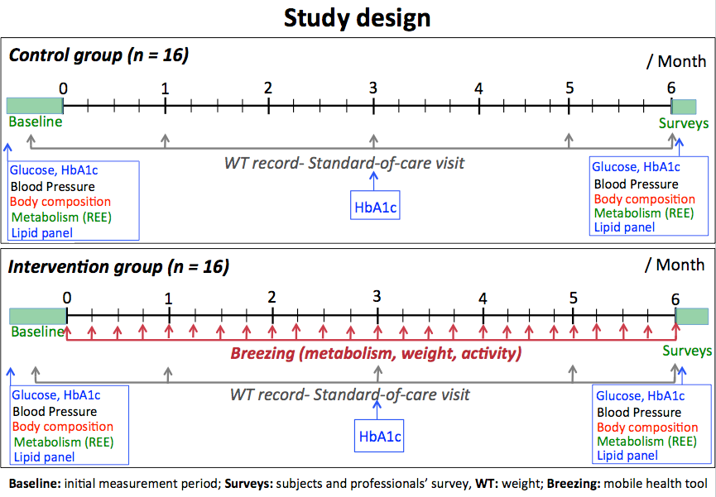

***Standard Care Group* (>16 participants)**

***Breezing Device Group* (>16 participants)**

**The measurement of Resting Energy Expenditure (REE)**

The REE testing will be done with the *Breezing* device, a breath analyzer developed at Arizona State University. The *Breezing* device (Figure 2) is an indirect calorimetry analyzer that measures the rate of oxygen consumption and carbon dioxide production, and determines how much energy the body is burning (REE), and the type of nutrients the body uses to produce energy (energy source). The *Breezing* device is a cellphone-size, battery-operated, portable technology that syncs with smartphones and electronic pads. You will be asked to breathe into a mouthpiece connected to the *Breezing* device; the data will be then beamed wirelessly to the device. The breath analysis data will displayed on the screen in conjunction with an estimate of total calories burned each day (total energy expenditure, TEE). The *Breezing* device has a 99.8% correlation with the best available methods used exclusively in the laboratory (Douglas Bag) making it a potential commercial product for weight management, fitness and health.

The *Breezing* analyzer will come with a disposable and sterilized mouthpiece that you will close your lips around while wearing a nose clip. You will then be asked to breathe into the mouthpiece for approximately 1 minute to collect the exhaled breath biomarkers. The results will be displayed and stored for further data analysis.



**Fig. 2**.

**RISKS**

As with any research, there is some possibility that you may be subject to risks that have not yet been identified. Potential risks may be associated with physical activities during the test, but in any case, you will be allowed to stop the activity if you feel uncomfortable with it or if you feel any physical discomfort.

**BENEFITS**

The possible/main benefits of your participation in the research are the access to the individual metabolic profile,

and elements to improve weight management

**NEW INFORMATION**

If the researchers find new information during the study that would reasonably change your decision about participating, then they will provide this information to you.

**CONFIDENTIALITY**

All information obtained in this study is strictly confidential unless disclosure is required by law. The results of this research study may be used in reports, presentations, and publications, but the researchers will not identify you. In order to maintain confidentiality, your records will be kept with researchers of this study, and the information will be maintained securely at the University of Arizona.

**WITHDRAWAL PRIVILEGE**

It is ok for you to say no. Even if you say yes now, you are free to say no later, and withdraw from the study at any time, and your decision will not affect your existing clinical care, relationship with your care providers or otherwise cause a loss of benefits to which you might otherwise be entitled. In addition, if you are a student, your nonparticipation or withdrawal from the study will not affect your grades or academic standing.

**COSTS AND PAYMENTS**

The researchers want your decision on participating in the study to be absolutely voluntary. Yet they recognize that your participation may pose some inconvenience. We will accommodate your schedule at the best convenience for you. You will be paid $25 after completing your 1, and 3 month visits. You will receive an additional $100 at the time of your 6 month visit. Upon your initial visit you will be issued an electronic pad to record and transmit your data to investigators. You will also receive an electronic scale to record your weights and/or a pocket activity monitor to record your physical movements. You will be able to keep these devices at the conclusion of the study.

**COMPENSATION FOR ILLNESS AND INJURY**

If you agree to participate in the study, then your consent does not waive any of your legal rights. However, no funds have been set aside to compensate you in the event of injury.

**VOLUNTARY CONSENT**

Any questions you have concerning the research study or your participation in the study, before or after your consent, will be answered by Craig Stump, Karen Herbst, Yulia Abidov, Shubh Preet Kaur, Ronnie Williams, University of Arizona, Tel: 520-626-3709 or 520-626-6376

If you have questions about your rights as a subject/participant in this research, or if you feel you have been placed at risk; you can contact the Chair of the Human Subjects Institutional Review Board, through the ASU Office of Research Integrity and Assurance, at 480-965 6788.

This form explains the nature, demands, benefits and any risk of the project. By signing this form you agree knowingly to assume any risks involved. Remember, your participation is voluntary. You may choose not to participate or to withdraw your consent and discontinue participation at any time without penalty or loss of benefit. In signing this consent form, you are not waiving any legal claims, rights, or remedies. A copy of this consent form will be given (offered) to you.

Your signature below indicates that you consent to participate in the above study.

___________________________ _________________________ ____________

Subject's Signature Printed Name Date

**INVESTIGATOR’S STATEMENT**

"I certify that I have explained to the above individual the nature and purpose, the potential benefits and possible risks associated with participation in this research study, have answered any questions that have been raised, and have witnessed the above signature. These elements of Informed Consent conform to the Assurance given by Arizona State University to the Office for Human Research Protections to protect the rights of human subjects. I have provided (offered) the subject/participant a copy of this signed consent document."

Signature of Investigator______________________________________ Date_____________